Software Requirements Specification
for
<Tetris Project>
Version 1.0 approved
Prepared by <Christopher D Koon>
<University of Advancing Technology, Group F>
<2/14/2019>
Table of Contents
Table of Contents ii
Revision History ii
1. Introduction 1
1.1 Purpose 1
1.2 Intended Audience and Reading Suggestions 1
1.3 Product Scope 1
2. Overall Description 2
2.1 Product Perspective 2
2.2 Product Functions 2
2.3 User Classes and Characteristics 2
2.4 Operating Environment 2
2.5 Design and Implementation Constraints 2
2.6 User Documentation 2
2.7 Assumptions and Dependencies 3
3. External Interface Requirements 3
3.1 User Interfaces 3
3.2 Hardware Interfaces 3
3.3 Software Interfaces 3
4. System Features 4
4.1 Use Case Diagram 4
4.2 Game State Diagram 4
5. Other Nonfunctional Requirements 4
5.1 Performance Requirements 4
5.2 Safety Requirements 5
5.3 Software Quality Attributes 5
5.4 Business Rules 5
6. Other Requirements 5
Appendix A: Glossary 5

Revision History
Name | Date | Reason For Changes | Version
Christopher Koon | 2/14/2019 | Initial Document Creation | 1.0.0

Introduction

Purpose
The purpose of this document is to outline the requirements of a Tetris game. This product will cover a main gameplay loop and GUI features. It will also support a save feature for high scores earned within the game.

Intended Audience and Reading Suggestions
This document is intended for project managers, QA/Testers and product developers.
Suggested Reading:
Project Managers – Sections 1.1 – 6.0
QA/Testers – Section 2 and 4
Product Developers – Section 4

Product Scope
The product being developed is Tetris clone game with graphical and high score features. Tetris is a 2D puzzle game that consists of a game board and tetrominoes. Tetrominoes are colored blocks that appear in one of 7 shapes each with a unique color. The user must guide the blocks to the bottom of the board to fill rows that will then clear. The cleared rows will reward the user with an increased score. The highest scores will then be saved to a local file.

Overall Description

Product Perspective
This project is a recreation of the classic Atari title “Tetris”. It will be available on the Windows platform and promises an enjoyable recollection of the classic title.

Product Functions
- Shape Creation
- Shape Rotation
- Artificial Gravity
- Line Clear
- Score Increase
- Save Score
- Game Over
- Graphical Interface

User Classes and Characteristics
TetrisProject is designed to be a casual game playable by anyone. The goal is to have a small application that may be ported and played on any Windows console. The application will be usable by anyone that can utilize a keyboard and mouse. The product is designed with casual competitive gameplay in mind, so the user will be able to play when it is convenient and only need to compete with high scores stored on their device.

Operating Environment
TetrisProject will only be available on the Windows PC platform. It will utilize a keyboard and mouse to control the gameplay.

Design and Implementation Constraints
TetrisProject will be written using C++ and the SFML library. The English language will be used to display all text options and menus. The application will operate on a Windows platform and use the system time to control the render pipeline. Project updates will not be supported after the release of the product.

User Documentation
Users will receive access to all supporting documentation to include a class diagram, state diagram, use case diagram, and project documentation. Users will also have access to the public SFML and C++ documentation web sites.

Assumptions and Dependencies
This product will use the SFML library. Reference the SFML documentation before changing or modifying this product.
This application will require the use of a Windows console. All users must run a Windows device to properly utilize this software.

External Interface Requirements

User Interfaces
Main Menu:
- Play Game (Begins the gameplay loop)
  - Right Arrow (Rotate Block Right)
  - Left Arrow (Rotate Block Left)
  - Down Arrow (Increase Block Fall Rate)
  - Esc Key (Return to main menu)
- Options (Displays options menu)
  - View High Scores (Displays current high scores)
  - Return to main menu (returns to main menu)
- Exit (Closes Application)

Hardware Interfaces
TetrisProject will use a keyboard and mouse to control the menus and gameplay. The following keys are required to play: Right Arrow, Left Arrow, Down Arrow, Esc Key.

Software Interfaces
The SFML library will be used for the rendering pipeline. This product will require the use of the Graphics module and system module from the library.

System Features

Use Case Diagram 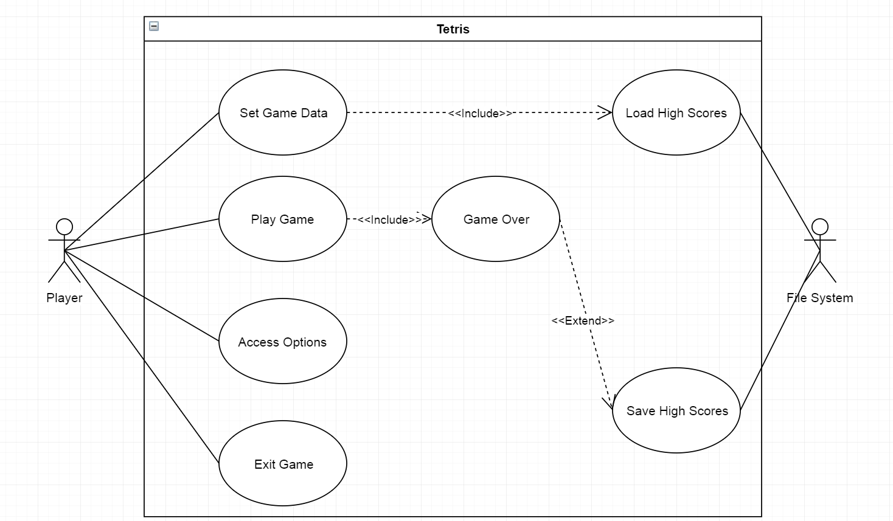

Main Gameplay Loop 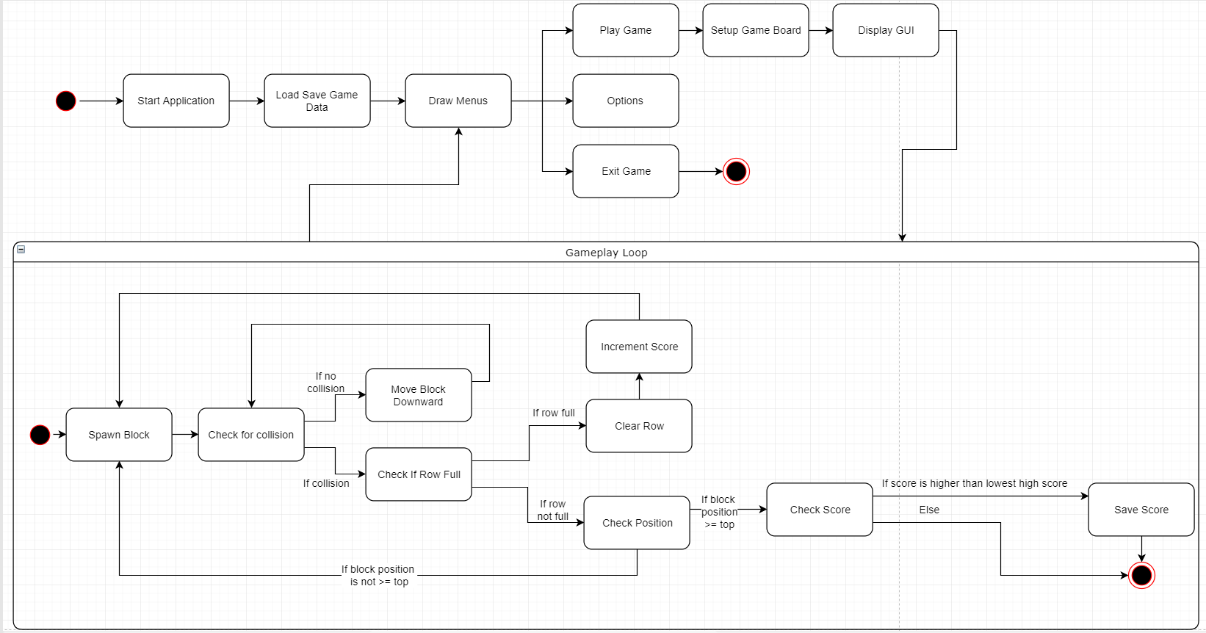

Application Start
4.1.1.1 Description and Priority
On starting the application load all high score data into the application. Low priority.
4.1.1.2 Stimulus/Response Sequences
Application start loads high score data and opens main menu.
4.1.1.3 Functional Requirements
REQ-1: Main Menu Functionality
REQ-2: Main Menu UI
REQ-3: High Score Data File

Main Menu
4.2.2.1 Description and Priority
Displays options available to user via mouse click for Play game, options menu and exit game. Medium Priority.
4.2.2.2 Stimulus/Response Sequences
On UI button click open the corresponding window, menu or close application.
4.2.2.3 Functional Requirements
REQ-1: Play game starts gameplay loop (See 4.2 Diagram)
REQ-2: Main menu de-renders
REQ-3: Main menu renders
REQ-4: Exit Game closes application

Gameplay Loop
4.2.3.1 Description and Priority
Main gameplay loop governs everything inside the gameplay itself. This is the block rotation, artificial gravity, block creation, line clears, and incrementing of the score. High Priority.
4.2.3.2 Stimulus/Response Sequences
Right arrow key will rotate the blocks right.
Left arrow key will rotate the blocks left.
Down arrow key will increase the rate the blocks fall.
4.2.3.3 Functional Requirements
REQ-1: Spawn blocks
REQ-2: Artificial gravity
REQ-3: Check for collisions
REQ-4: Check position (loss condition if block is too high)
REQ-5: Clear row
REQ-6: Increment score
REQ-7: Save high score

Graphics
4.2.4.1 Description and Priority
Provide an interactable user interface for the user to have a more aesthetically pleasing experience. Low priority.
4.2.4.2 Functional Requirements
REQ-1: Sprite creation
REQ-2: Render sprites by shape
REQ-3: Render game board
REQ-4: Render main menu UI
REQ-5: Render gameplay loop changes

Other Nonfunctional Requirements

Performance Requirements
This product is to be run on a Windows PC console. Use of system timer events should be kept to a minimum to reduce the time between frame draws from the SFML library.

Safety Requirements
Peoples sensitive to light or prone to epileptic seizures should not use this product as prolonged use may cause health complications such as dizziness, altered vision, twitches, loss of awareness, disorientation, seizures or involuntary movement.

Software Quality Attributes
All development must be written with minimal complexity to ensure it remains adaptable to the academic environment and promote teamwork and collaboration. The development of this project must be suitable for the academic environment.

Business Rules
This product may not be sold or distributed as an original intellectual property. All rights to Tetris belong to Tetris Co. and must be used for educational purposes only.

Other Requirements
All rights to Tetris and have a likeness to the original Tetris belong to Tetris Co. This product must not be sold or distributed as an original intellectual property.
Appendix A: Glossary
- SFML – High level C++ graphics library
- Blocks – Tetromino shape
- Tetrominoes – Block in one of several layouts including 4 1x1 blocks.

